Chapter 9, Problem 45.

Find current I_{o} in the network of Fig. 9.52.

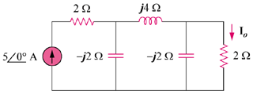
35∠0º A

Figure 9.52
For Prob. 9.45.

